**Color-Color Plot Project**

General:

The goal of this project is to make sense of a color-color plot that was produced from a big catalogue of Spitzer data called the SEIP. The general description of the SEIP is [here](http://irsa.ipac.caltech.edu/data/SPITZER/Enhanced/SEIP/overview.html).

Description of the original NITARP project that got us to this point is [here](https://drive.google.com/drive/#folders/0B-HF3eq9oiXuVzBQalJPY2VZc1E/0B7fF5q8GqSk9VWJVUVp2bGpFejA). Note: it may be best to download this poster. I don’t think it shows up well on the Google Drive. Pay particular attention to the “Selection of Color Outliers” figure. In the original project, we were looking at the yellow outlier points, and we pretty much ignored all of the blue stuff. Now it is time to investigate further the blue blob. Notice the four-lobed structure? This thing is just begging to be looked at in more detail.

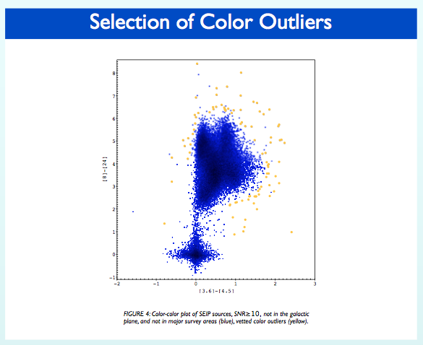

[Here’s](http://coolwiki.ipac.caltech.edu/index.php/Color-Magnitude_and_Color-Color_plots) some information on color-color and color magnitude plots.

Classification Schemes:

Okay, once you know a bit about color-color plots, you can try reading [this](https://drive.google.com/drive/#folders/0B44FvvLeyjLKfnRJNS1fXzZ5dy03SUhkcThNN29MbERZT3Z5RzM1aXVuRWJKa0VvUjBpUjQ) article. It describes a classification scheme used with WISE data to sort out YSO from large samples of random sources. If you want a general description of what is going on here, you can watch this recorded [video conference](https://www.youtube.com/watch?v=YdPTpmAxpCc) where it is explained -- start at around 20 minutes into the call.

There are other classification schemes like this that have been done for Spitzer data (that’s what we have). One is called the Gutermuth method. You can read about it [here](http://coolwiki.ipac.caltech.edu/index.php/Gutermuth_color_selection), and you can also follow the links to the original paper.

TopCat:

So how are you going to make the kinds of plots described in these methods? Well, there is an awesome plotting program called [Topcat](http://www.star.bris.ac.uk/~mbt/topcat/) that is really powerful and awesome, and it is free!!! Go download it, because you’re going to need it, and then watch Sarp’s video tutorial on how to use it, [here](https://drive.google.com/drive/#folders/0B-HF3eq9oiXuVzBQalJPY2VZc1E/0B7fF5q8GqSk9YWU5SkpBOWh1ZU0). Here’s an [outline](https://docs.google.com/document/d/1xNUkaabmLwyL1Go4xA440JBw9YP8go4YZLS4llqmHh0/edit) of the tutorial.

Here is the [entire SEIP](https://drive.google.com/drive/#folders/0B-HF3eq9oiXuVzBQalJPY2VZc1E/0B7fF5q8GqSk9QzRJYVVQQmdnbWM/0B7fF5q8GqSk9UGQ1TVJ4bEpRckk) for snr>10. We’ll probably also need some other things here. Others should feel free to add links.

Lists of Known Sources:

One of the things that is definitely necessary for this project is to have some catalogues of known sources that have been imaged in Spitzer wavelengths. I asked Luisa Rebull to help me with this, and here’s what she gave me:

“There are other ones for other objects (just as there are other ones for WISE), but I know YSOs best, so this is the place I’d start. One of the training sets for Xavier was my big Taurus database. A version of the catalog of YSOs is linked in here:

<http://coolwiki.ipac.caltech.edu/index.php/Taurus_catalog>

along with some important information (caveats, etc.) about this catalog. You could grab our entire Taurus catalog (foreground/background stars and background galaxies) here :

<http://irsa.ipac.caltech.edu/data/SPITZER/Taurus/>

and use that as a training set to see if you can recover most of the YSOs in the shortlist above. There’s lots of plain stars and LOTS AND LOTS of galaxies. Many of them can be identified as galaxies from the data that are now (but weren’t then) available via FinderChart:

<http://irsa.ipac.caltech.edu/applications/finderchart/>

There are other similar large fields with which you could do the same exercise, but Taurus is the closest star forming region, so it’s likely to be the most complete sample we have (e.g., going down to brown dwarfs, whereas further away star forming regions may only go do to mid-M stars). If you want more, though, many are here:

<http://irsa.ipac.caltech.edu/data/SPITZER/C2D/>

The field I mentioned today that was just stars and distant galaxies was one of the SWIRE fields - SWIRE ELAIS N1 as I recall. Those catalogs are also available online —

<http://irsa.ipac.caltech.edu/data/SPITZER/SWIRE/>

But I used the c2d version of the resampled SWIRE to match the selection effects in c2d.”